**ASSIGNMENT - 2**

**NAME : NALADALA NAVYA**

**REG NO : 21BCE7791**

Kali Linux is a popular penetration testing and ethical hacking distribution that comes preloaded with a wide range of powerful tools for various cybersecurity tasks. Here, a detailed overview of 10 essential Kali Linux tools:

1. **Nmap (Network Mapper):**

- Nmap is a versatile network scanning tool that serves as the go-to choice for discovering hosts, services, and potential vulnerabilities within a network. Its capabilities include host discovery, service and version detection, OS fingerprinting, and the ability to run scripted scans. Security professionals frequently use Nmap as the first step in network reconnaissance to gain insights into a target environment's architecture and potential security weaknesses.

**Purpose:** Nmap is a network scanning tool used for discovering hosts and services on a network.

**Features:** It can perform various types of scans, such as TCP, UDP, OS detection, and version detection. Nmap helps identify open ports, services running on them, and potential vulnerabilities.

**Usage**: `nmap -sV -A target_IP`

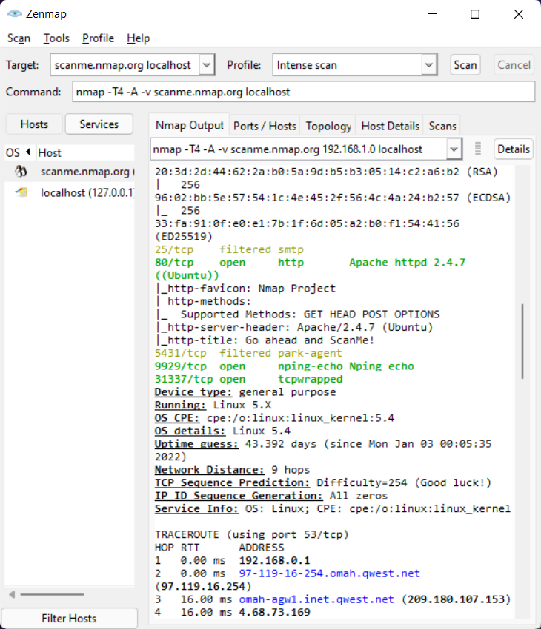

**2. Wireshark:**

- Wireshark is a robust packet analysis tool that allows security experts and network administrators to capture and dissect network traffic. This tool is indispensable for troubleshooting network issues, identifying security breaches, and comprehensively understanding network protocols. Wireshark's user-friendly interface and extensive protocol support make it a cornerstone in network analysis and forensics.

**Purpose:** Wireshark is a popular network protocol analyzer used for capturing and analyzing network traffic.

**Features:** It allows you to inspect packets in real-time, filter traffic, and dissect protocols. Wireshark is invaluable for troubleshooting network issues and understanding network communication.

**Usage:** `wireshark`

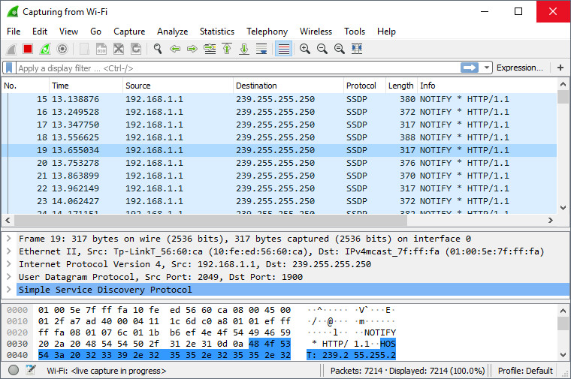

**3.Metasploit Framework:**

-The Metasploit Framework is an industry-standard penetration testing toolset known for its extensive collection of exploits, payloads, and post-exploitation modules. It is a must-have for security professionals and ethical hackers who aim to simulate real-world attacks, identify vulnerabilities, and validate security measures. Metasploit simplifies the process of identifying and exploiting vulnerabilities in systems, making it an invaluable resource for security assessments.

**Purpose:** Metasploit is a powerful penetration testing tool that helps find, exploit, and validate vulnerabilities in systems.

**Features:** It offers a vast collection of exploits, payloads, and auxiliary modules. Security professionals use Metasploit to simulate real-world attacks and assess the security of systems.

**Usage:** `msfconsole`

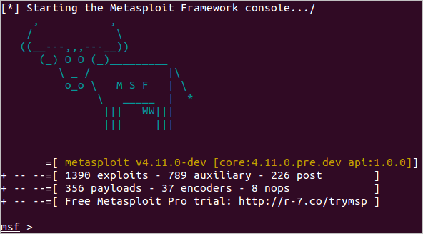

1. **Aircrack-ng:**

- Aircrack-ng is a comprehensive suite of tools tailored for assessing the security of wireless networks. Its capabilities include capturing and analyzing Wi-Fi traffic, testing WEP and WPA/WPA2 encryption, and conducting dictionary attacks to recover Wi-Fi passwords. This tool is indispensable for evaluating the security posture of wireless networks.

**Purpose:** Aircrack-ng is a suite of tools used for assessing and cracking Wi-Fi network security.

**Features**: It includes utilities for capturing packets, testing WEP and WPA/WPA2 encryption, and conducting dictionary attacks on Wi-Fi passwords.

**Usage:** `aircrack-ng -w wordlist -b target_BSSID`

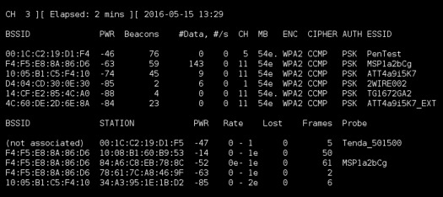

1. **Hydra:**

- Hydra is a specialized password-cracking tool designed to identify weak authentication credentials on various network services. It supports protocols such as SSH, FTP, HTTP, and more, making it an indispensable asset for security assessments. Security professionals utilize Hydra to assess the strength of passwords and improve overall security by identifying and rectifying weak access credentials.

**Purpose:** Hydra is a popular password-cracking tool that supports various protocols.

**Features:** It can perform dictionary and brute-force attacks against services like SSH, FTP, HTTP, and more. Hydra helps testers identify weak or easily guessable passwords.

**Usage:** `hydra -l username -P password_list target_protocol://target_IP`

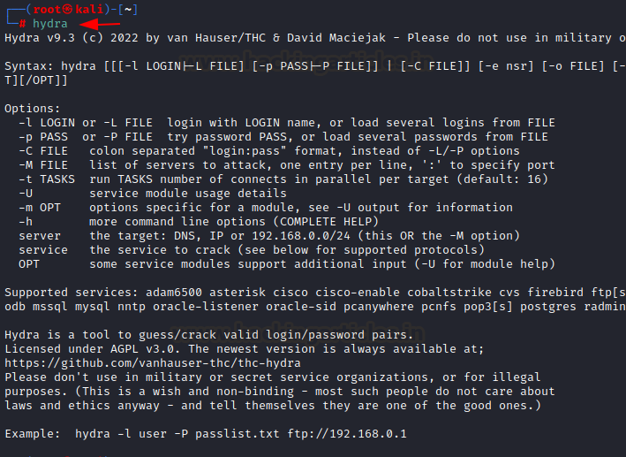

**6. Burp Suite:**

- Burp Suite is an essential tool for web application security testing. It encompasses a range of functionalities, including web vulnerability scanning, crawling, and automated testing. Security testers use Burp Suite to discover and assess vulnerabilities in web applications, providing an effective means of securing online assets against potential threats.

**Purpose:** Burp Suite is a web application security testing tool used for scanning and testing web applications.

**Features:** It includes features like web vulnerability scanning, crawling, and automated testing. Burp Suite is widely used by web application security testers to identify and fix vulnerabilities.

**Usage:** Launch `burpsuite` from the terminal.

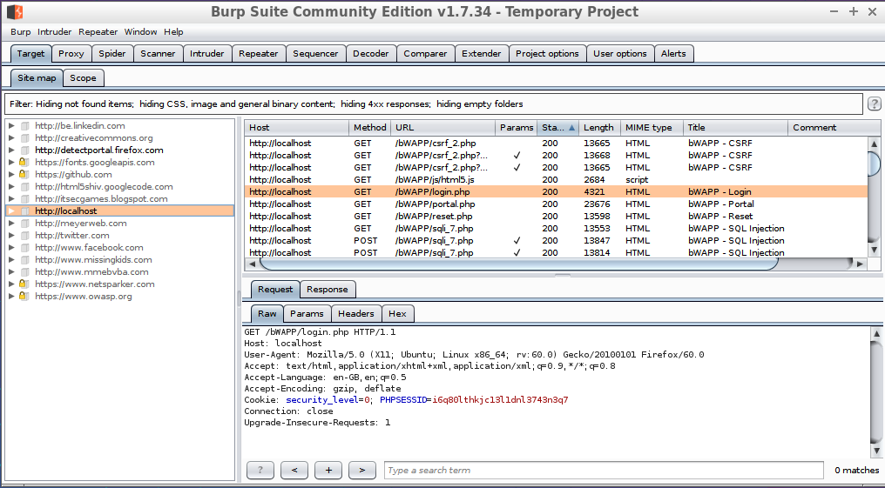

**7.John the Ripper:**

-John the Ripper is a widely recognized password-cracking tool renowned for its efficiency in deciphering password hashes. It supports various password hash algorithms and can execute dictionary and brute-force attacks. Security professionals leverage John the Ripper to assess password security and identify weak or vulnerable credentials.

**Purpose:** John the Ripper is another popular password-cracking tool primarily used for Unix-based systems.

**Features:** It supports various password hash algorithms and can perform dictionary attacks and brute-force attacks on password hashes.

**Usage:** `john --wordlist=wordlist.txt --format=hash_type target_hash_file`

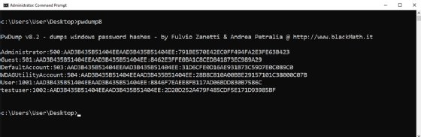

1. **Gobuster:**

- Gobuster is a versatile directory and file brute-forcing tool utilized during web application testing. Security testers employ Gobuster to uncover hidden files and directories on web servers by systematically attempting various path and filename combinations. This tool plays a crucial role in identifying potential vulnerabilities in web applications.

**Purpose:** Gobuster is a directory and file brute-forcing tool used for web application testing.

**Features:** Security professionals use Gobuster to discover hidden files and directories on web servers by trying various paths and filenames.

- Usage: `gobuster dir -u http://target_url -w wordlist.txt`

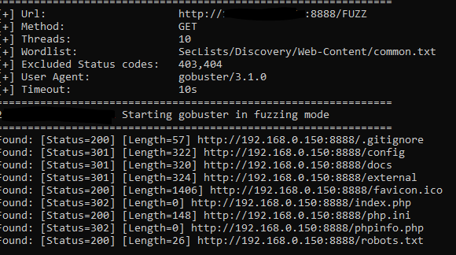

1. **Nikto:**

- Nikto is a specialized web server vulnerability scanner that automates the process of identifying and assessing security flaws in web applications and servers. It scans for known vulnerabilities, misconfigurations, and common issues, providing security professionals with valuable insights to enhance web application security.

**Purpose:** Nikto is a web server vulnerability scanner that identifies potential security issues in web applications.

**Features:** It scans for known vulnerabilities, misconfigurations, and common security flaws in web servers and web applications.

**Usage:** `nikto -h target_URL`

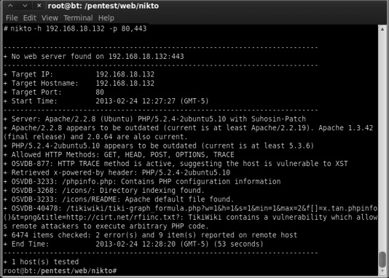

**10..SQLMap:**

- SQLMap is a powerful automated tool designed to identify and exploit SQL injection vulnerabilities in web applications. Its functionality includes detecting and exploiting SQL injection flaws, potentially gaining unauthorized access to databases. Security testers rely on SQLMap to assess and enhance the security of web applications that interact with databases.

**Purpose:** SQLMap is an automated SQL injection testing tool used for detecting and exploiting SQL injection vulnerabilities in web applications.

**Features:** It automates the process of identifying and exploiting SQL injection flaws, making it a valuable tool for database security assessments.

**Usage:** `sqlmap -u "target_URL" --dbs`

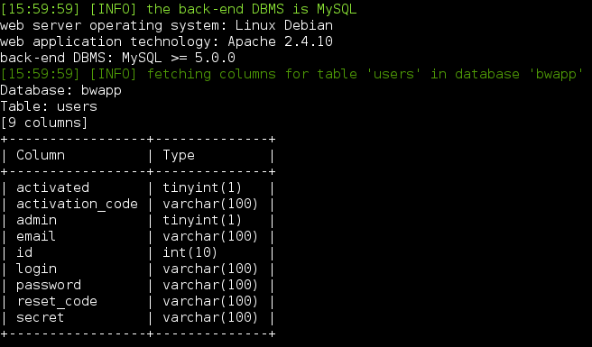

Remember that these tools should only be used for ethical and legal purposes, such as penetration testing on systems you have explicit permission to test. Unauthorized use can lead to legal consequences. Always adhere to ethical guidelines and applicable laws when using these tools.